Machine learning

Contents
- Basics
  - Supervised,unsupervised,reinforcement
  - Bias-variance trade-off
  - Overfitting, underfitting
- Gradient descent:-batch,stochastic
- Resampling methods
  - Bootstrapping
  - Cross-Validation
- Linear discriminant analysis (LDA)
- Principal Component Analysis(PCA)
- Learning Vector Quantization (LVQ)
- Regularization methods:- Ridge,LASSO
- Kernel smoothing methods
- Ensemble learning:-Bagging(bootstrap aggregation),boosting,stacking,blending
- Ordinary least squares
- Partial Least squares
- Kernel density Estimation
- Radial basis functions
- Multi co-linearity :Detection(Tolerance,VIF,correlation matrix) and treatment
- AIC,BIC
- K-fold cross validation
- Generalized Additive Models (GAMs)
- Multivariate Adaptive Regression Splines(MARS)
- Gradient boosting
- NLP
  - Word sense disambiguation
  - Pronoun resolution
  - Machine translation
  - Tokenization
  - Regular expressions
  - Stemming
  - Lemmatization
- Evaluation metrics
  - AUC
  - Precision
  - Recall
  - Specificity
  - Mean absolute percentage error
  - Root mean square error
- Algorithms
  - Linear regression: Usually performed through OLS
  - Logistic regression
  - Naive Bayes
  - K-Nearest Neighbors
  - K means clustering
  - Classification and regression trees(CARTs)
  - Support vector machines
  - AdaBoost
  - Random forest
  - ARIMA
  - Decision Trees
  - ID3
  - CHAID
  - C4.5, C5.0
  - Hierarchical Clustering
- Miscellaneous
  - Curse of dimensionality
  - No free lunch theorem
  - Occams Razor
- Deep Learning
  - Neural Networks
  - Bayesian neural nets
  - Deep Boltzmann Machine(DBM)
  - Deep Belief Networks(DBN)
  - Convolutional Neural Networks
- Stats
  - Hypothesis testing
    - Confidence intervals
    - P-value
    - different types of tests
  - Types of Sampling
  - Scedasticit

1. basic
types :
Supervised,unsupervised,reinforcement

in supervised learning : label data
unsupervised learning : model sense and make the decision according to it
reinforcement learning: agent sense environment and take an decision and based on this decision agent might get compliment or punished .

Bias-variance trade-off

its task for finding optimal bias and variance

What is bias?
Bias is the difference between the average prediction of our model and the correct value which we are trying to predict. Model with high bias pays very little attention to the training data and oversimplifies the model. It always leads to high error on training and test data.
What is variance?
Variance is the variability of model prediction for a given data point or a value which tells us spread of our data. As a result, such models perform very well on training data but has high error rates on test data.

Overfitting, underfitting

underfitting:
(high bias) not generalized data well due to that gives error in training set too

overfitting: (high vairance)
model generalize data soo good that it produce error in unseen data

2 Gradient descent:-batch,stochastic

https://ml-cheatsheet.readthedocs.io/en/latest/gradient_descent.html

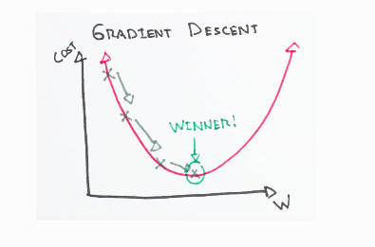

changing parameters to get minimum error gradient decent is generalize term for derivatives involving multiple parameters

https://www.youtube.com/watch?v=4qJaSmvhxi8

https://www.youtube.com/watch?v=-_4Zi8fCZO4

batch : involve training model on whole dataset useful for whwn dataset is small

mini-batch : in this method data-set is divided into multiple batches , and training done onto those multiple mini batches . Each training cycle for one part of data-set is known as 1-epoch.

Stochastic : batch size 1 u do train model for each example separately

3 re-sampling method

https://medium.com/analytics-vidhya/resampling-methods-statistical-learning-8c3da6fe6d24

what is model -
Loosely speaking, this mathematical description is called a model. That model often takes inputs and produces outputs based on the data we have, and we want to use that model to predict or explain future data. It could produce data that can take any value (sometimes within a range):this is regression. Or there could be a set of discrete choices, called classification. Together, these two comprise most of what is called supervised learning

Resampling methods are processes of repeatedly drawing samples from a data set and refitting a given model on each sample with the goal of learning more about the fitted model
cross validation is used to asses the flexibility of model
bootstrapping gives measure of accuracy of model

https://www.youtube.com/watch?v=gcPIyeqymOU

bootstrapping method :
The sampling employed by the bootstrap involves randomly selecting n observations with replacement, which means some observations can be selected multiple times while other observations are not included at all.
This process is repeated B times to yield B bootstrap data sets, Z∗1,Z∗2,…,Z∗B,which can be used to estimate other quantities such as standard error.

Cross-Validation method:
The validation set approach involves randomly dividing the available observations into two groups, a training set and a validation or hold-out set. The model is then fit using the training set and then the fitted model is used to predict responses for the observations in the validation set.

4 Linear discriminant analysis (LDA) Principal Component Analysis(PCA)

https://sebastianraschka.com/Articles/2014_python_lda.html

Linear Discriminant Analysis (LDA) is most commonly used as dimensionality reduction technique in the pre-processing step for pattern-classification and machine learning applications. The goal is to project a dataset onto a lower-dimensional space with good class-separability in order avoid overfitting (“curse of dimensionality”) and also reduce computational costs

In machine learning classification problems, there are often too many factors on the basis of which the final classification is done. These factors are basically variables called features. The higher the number of features, the harder it gets to visualize the training set and then work on it. Sometimes, most of these features are correlated, and hence redundant. This is where dimensionality reduction algorithms come into play. Dimensionality reduction is the process of reducing the number of random variables under consideration, by obtaining a set of principal variables. It can be divided into feature selection and feature extraction.

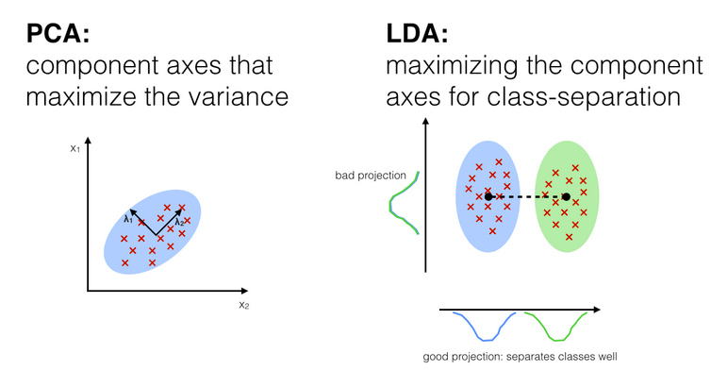

PCA can be described as an “unsupervised” algorithm, since it “ignores” class labels and its goal is to find the directions (the so-called principal components) that maximize the variance in a dataset. In contrast to PCA, LDA is “supervised” and computes the directions (“linear discriminants”) that will represent the axes that that maximize the separation between multiple classes.

Method of dimensionalilty reduction
Feature Elimination : drooping some of features so that less features to be considered
Feature Extraction : dropping least required feature and make new independent variable based on old variables ( new variable made with specific combination and in particular order of old variable)
https://towardsdatascience.com/a-one-stop-shop-for-principal-component-analysis-5582fb7e0a9c

